WeifengLai (001561798)

**Program Structures & Algorithms**

**Fall 2021**

**Assignment No. 1**

**Q1: Your conclusion about the relationship between d and n**

**A: The relationship between d and n, where n is number of step and d is Euclidean distance between final coordinate and the origin, is that d is almost like square root of n, as well as:**

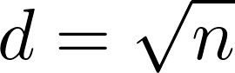

**Q2: Your evidence to support that relationship (screen shot and/or graph and/or spreadsheet)**

**A: I got pairs (d, n) from step value `n` and euclidean distance `d` between final coordinate and the origin after performing six different step values {16, 25, 49, 81, 100, 169} in 1000 times for each, like following:**

**(16, 3.60)**

**(25, 4.32)**

**(49, 6.25)**

**(81, 8.02)**

**(100, 8.94)**

**(169, 11.73)**

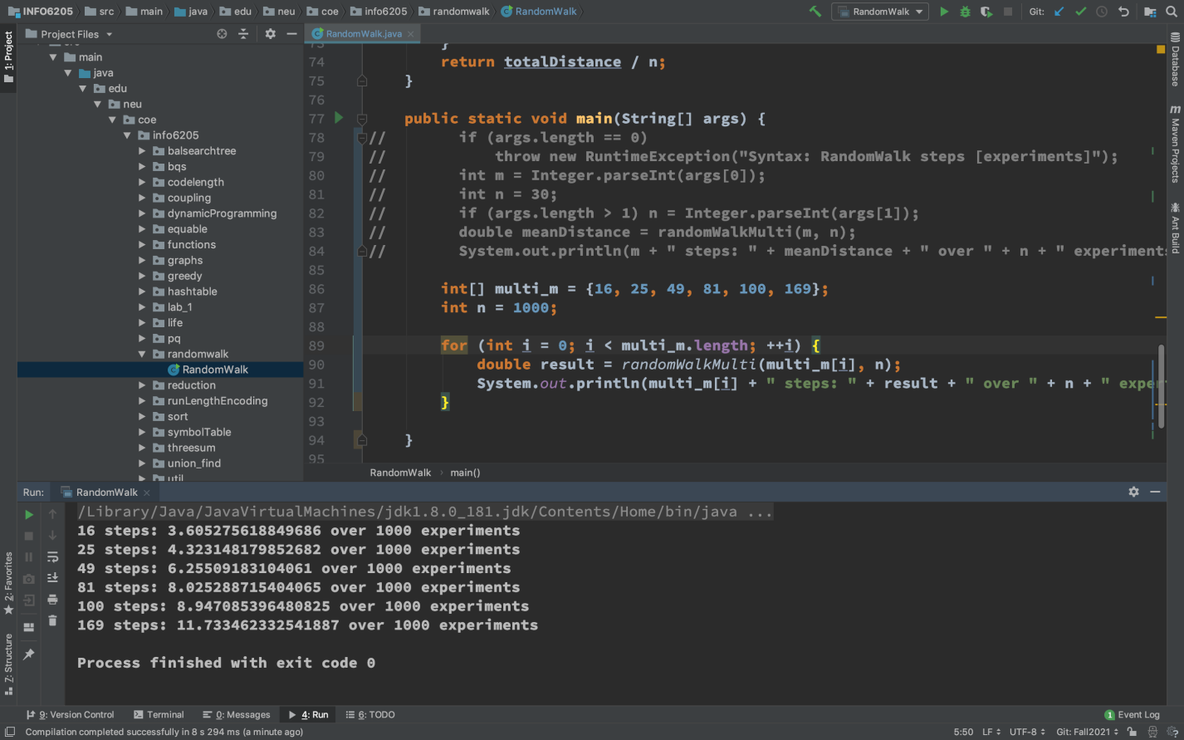

**I drew these points on coordinate system, then fitted curve.**

**I found out it is similar to the curve of square root function. the following is points with same x value above:**

**(16, 4)**

**(25, 5)**

**(49, 7)**

**(81, 9)**

**(100, 10)**

**(169, 13)**

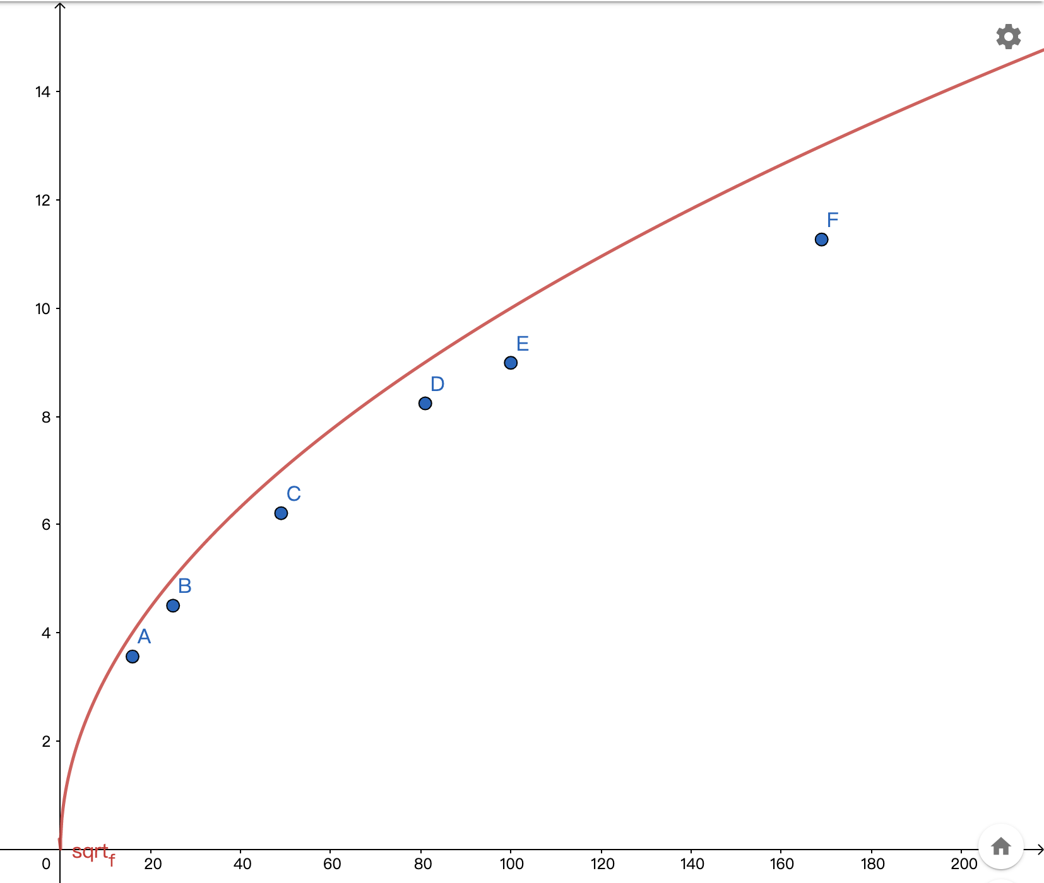

**Therefore I guess the relationship between `d` and `n` is that: d is almost square root value of n.**

**Q3: Your code (RandomWalk.java plus anything else that you changed or created)**

**A: Please take a look at attachment of source code. My modified file (RandomWalk.java) is included in it and locates in path `INFO6205/src/main/java/edu/neu/coe/info6205/randomwalk/RandomWalk.java`.**

**Q4: A screen shot of the unit tests all passing**

**A: Screen shot of the unit tests is as following:**

